ST. XAVIER’S COLLEGE

**Maitighar, Kathmandu**



**Computer Graphics**

**Lab Assignment #1**

**SUBMITTED BY:**

**Siddhant Rimal**

**013BSCCSIT039**

**SUBMITTED TO**

|  |  |
| --- | --- |
| **Er. Anil Sah**  **( Lecturer )** |  |
| **Department of Computer Science** | |

Submission Date: August 4th 2015

**OBJECTIVE 1.1: TO BUILD A SIMPLE CALCULATOR**

|  |
| --- |
| **Source Code:** |
| //--------------------------------------------------------------------------- |
| #include <vcl\vcl.h> |
| #pragma hdrstop |
|  |
| #include "SimCalc.h" |
| //--------------------------------------------------------------------------- |
| #pragma resource "*.dfm" |
| int clickno=0, showno=0, modflag=0,storeno=0, oflag=0,addflag=0,minflag=0, mulflag=0,divflag=0; |
| TForm1 *Form1; |
| //--------------------------------------------------------------------------- |
| __fastcall TForm1::TForm1(TComponent* Owner) |
| : TForm(Owner) |
| { |
|  |
| } |
| //--------------------------------------------------------------------------- |
| void __fastcall TForm1::Button7Click(TObject *Sender) |
| { |
| if (oflag==1) |
| { |
| showno=storeno; |
| oflag=0; |
| storeno=0; |
| } |
| clickno=1; |
| showno=showno*10+clickno; |
| Edit1->Text=showno; |
|  |
| } |
| //--------------------------------------------------------------------------- |
| void __fastcall TForm1::Button8Click(TObject *Sender) |
| { |
| if (oflag==1) |
| { |
| showno=storeno; |
| oflag=0; |
| storeno=0; |
| } |
| clickno=2; |
| showno=showno*10+clickno; |
| Edit1->Text=showno; |
|  |
| } |
| //--------------------------------------------------------------------------- |
| void __fastcall TForm1::Button9Click(TObject *Sender) |
| { |
| if (oflag==1) |
| { |
| showno=storeno; |
| oflag=0; |
| storeno=0; |
| } |
| clickno=3; |
| showno=showno*10+clickno; |
| Edit1->Text=showno; |
|  |
| } |
| //--------------------------------------------------------------------------- |
| void __fastcall TForm1::Button4Click(TObject *Sender) |
| { |
| if (oflag==1) |
| { |
| showno=storeno; |
| oflag=0; |
| storeno=0; |
| } |
| clickno=4; |
| showno=showno*10+clickno; |
| Edit1->Text=showno; |
|  |
| } |
| //--------------------------------------------------------------------------- |
| void __fastcall TForm1::Button5Click(TObject *Sender) |
| { |
| if (oflag==1) |
| { |
| showno=storeno; |
| oflag=0; |
| storeno=0; |
| } |
| clickno=5; |
| showno=showno*10+clickno; |
| Edit1->Text=showno; |
|  |
| } |
| //--------------------------------------------------------------------------- |
| void __fastcall TForm1::Button6Click(TObject *Sender) |
| { |
| if (oflag==1) |
| { |
| showno=storeno; |
| oflag=0; |
| storeno=0; |
| } |
| clickno=6; |
| showno=showno*10+clickno; |
| Edit1->Text=showno; |
|  |
| } |
| //--------------------------------------------------------------------------- |
| void __fastcall TForm1::Button1Click(TObject *Sender) |
| { |
| if (oflag==1) |
| { |
| showno=storeno; |
| oflag=0; |
| storeno=0; |
| } |
| clickno=7; |
| showno=showno*10+clickno; |
| Edit1->Text=showno; |
|  |
| } |
| //--------------------------------------------------------------------------- |
| void __fastcall TForm1::Button2Click(TObject *Sender) |
| { |
| if (oflag==1) |
| { |
| showno=storeno; |
| oflag=0; |
| storeno=0; |
| } |
| clickno=8; |
| showno=showno*10+clickno; |
| Edit1->Text=showno; |
|  |
| } |
| //--------------------------------------------------------------------------- |
| void __fastcall TForm1::Button3Click(TObject *Sender) |
| { |
| if (oflag==1) |
| { |
| showno=storeno; |
| oflag=0; |
| storeno=0; |
| } |
| clickno=9; |
| showno=showno*10+clickno; |
| Edit1->Text=showno; |
|  |
| } |
| //--------------------------------------------------------------------------- |
| void __fastcall TForm1::Button10Click(TObject *Sender) |
| { |
| if (oflag==1) |
| { |
| showno=storeno; |
| oflag=0; |
| storeno=0; |
| } |
| clickno=0; |
| showno=showno*10+clickno; |
| Edit1->Text=showno; |
|  |
| } |
| //--------------------------------------------------------------------------- |
| void __fastcall TForm1::Button11Click(TObject *Sender) |
| { |
| oflag=0; |
| storeno=storeno+showno; |
| Edit1->Text=" + "; |
| clickno=0; |
| showno=0; |
| addflag=1; |
| } |
| //--------------------------------------------------------------------------- |
| void __fastcall TForm1::Button15Click(TObject *Sender) |
| { |
| if (addflag==1) |
| storeno=showno+storeno; |
| if (minflag==1) |
| storeno=storeno-showno; |
| if (mulflag==1) |
| storeno=showno*storeno; |
| if (divflag==1) |
| storeno=storeno/showno; |
| if (modflag==1) |
| storeno=storeno%showno; |
|  |
| Edit1->Text=storeno; |
|  |
| addflag=0; |
| minflag=0; |
| mulflag=0; |
| divflag=0; |
| modflag=0; |
| clickno=0; |
| showno=0; |
| oflag=1; |
| } |
| //--------------------------------------------------------------------------- |
| void __fastcall TForm1::Button12Click(TObject *Sender) |
| { |
| oflag=0; |
| storeno=storeno+showno; |
| Edit1->Text=" - "; |
| clickno=0; |
| showno=0; |
| minflag=1; |
| } |
| //--------------------------------------------------------------------------- |
| void __fastcall TForm1::Button13Click(TObject *Sender) |
| { |
| oflag=0; |
| storeno=storeno+showno; |
| Edit1->Text=" x "; |
| clickno=0; |
| showno=0; |
| mulflag=1; |
| } |
| //--------------------------------------------------------------------------- |
| void __fastcall TForm1::Button14Click(TObject *Sender) |
| { |
| oflag=0; |
| storeno=storeno+showno; |
| Edit1->Text=" / "; |
| clickno=0; |
| showno=0; |
| divflag=1; |
| } |
| //--------------------------------------------------------------------------- |
| void __fastcall TForm1::Button17Click(TObject *Sender) |
| { |
| modflag=0;clickno=0;showno=0; storeno=0; oflag=0;addflag=0;minflag=0; mulflag=0;divflag=0; |
| Edit1->Text=0; |
| } |
| //--------------------------------------------------------------------------- |
| void __fastcall TForm1::Button16Click(TObject *Sender) |
| { |
| oflag=0; |
| storeno=storeno+showno; |
| Edit1->Text=" MODULUS "; |
| clickno=0; |
| showno=0; |
| modflag=1; |
| } |
| //--------------------------------------------------------------------------- |
| void __fastcall TForm1::Button18Click(TObject *Sender) |
| { |
| modflag=0;clickno=0;showno=0; storeno=0; oflag=0;addflag=0;minflag=0; mulflag=0;divflag=0; |
| Edit1->Text=""; |
| } |
| //--------------------------------------------------------------------------- |

**OUTPUT:**

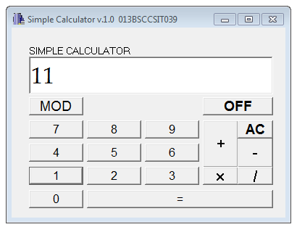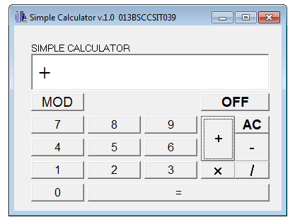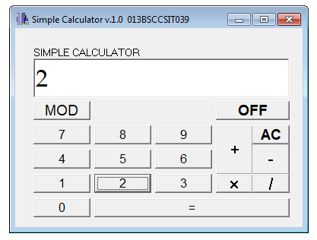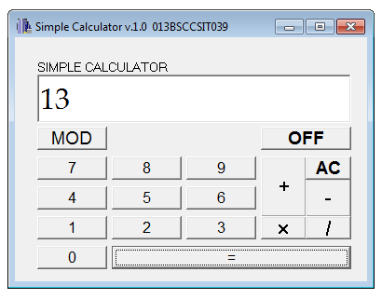

Fig: Addition Operation in Simple Calculator

**CONCLUSION:**

The program could perform simple integer calculation problems such as addition, subtraction, multiplication, division and finding modulus. This is a simple integer calculator thereby unable to handle decimal calculations.

**OBJECTIVE 1.2: TO MAKE A CHECKERED BOX**

|  |
| --- |
| SOURCE CODE: |
| //--------------------------------------------------------------------------- |
| #include <vcl\vcl.h> |
| #pragma hdrstop |
|  |
| #include "CB.h" |
| //--------------------------------------------------------------------------- |
| #pragma resource "*.dfm" |
| TForm1 *Form1; |
| int l=50,b=250,i,j,x,y; |
| //--------------------------------------------------------------------------- |
| __fastcall TForm1::TForm1(TComponent* Owner) |
| : TForm(Owner) |
| { |
| Image1->Canvas->Pen->Width=3; |
| Image1->Canvas->Brush->Color=clRed; |
| Image1->Canvas->Rectangle(l,l,b,b); |
| Image1->Canvas->MoveTo(l,l); |
| Image1->Canvas->LineTo(b,b); |
| Image1->Canvas->MoveTo(b,l); |
| Image1->Canvas->LineTo(l,b); |
|  |
| for(i=1;i<=3;i++) |
| { |
| x=x+50; |
| Image1->Canvas->MoveTo(l+x,l); |
| Image1->Canvas->LineTo(l+x,b); |
| y=y+50; |
| Image1->Canvas->MoveTo(l,l+y); |
| Image1->Canvas->LineTo(b,l+y); |
| } |
|  |
| } |
| //-- |

**OUTPUT:**

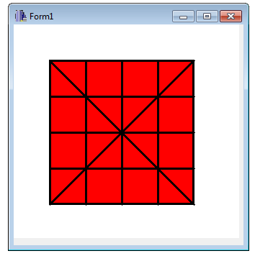

Fig: A checkered box

**CONCLUSION:**

It is possible to make a checkered box using the Rectangle, MoveTo, LineTo and other associated graphical functions in C++ Builder.